|  |
| --- |
| ***Worship Calendar***  Tuesday, December 24, **Christmas Eve**  11:00 a.m. **Holy Eucharist**  4:00 p.m. **Blessing of the Creche & Holy Eucharist** (Ukulele Ministry)  7:00 p.m. **Holy Eucharist**  Sunday, December 29, **Sunday after Christmas**  10:30 a.m. **Christmas Lessons & Carols**  Sunday, January 5, **The Epiphany of Our Lord**  10:30 a.m. **Family Eucharist**  Followed by a Cup O’Tea in the Parish Hall |

Parish Office Christmas Hours

The Parish Office will be **closed** from **Tuesday, December 24th to Thursday, January 2nd 2025 inclusive.**

We will open on **Monday, December 30th**, for year- end counting and deposit only.

Regular office hours (9:00 a.m. to 1:00 p.m.) will resume on **Monday, January 6th, 2025**

A locked mail drop box is available at the office entrance for your convenience.

If you have an emergency during the Christmas season, please contact: Reverend Jotie @ 709 325-2366

***Service Roster:*** Sidespersons Sound Room

December 24th Bob D./ Jim S. / Philip G.

December 29th Andrew B.

|  |
| --- |
| Bishop: The Right Dr. Reverend Samuel Rose  Diocesan Administrator: The Venerable Charlene Taylor  Rector: The Reverend Canon Josiah “Jotie” Noel, T.S.S.F. (Third Order, Society of St. Francis)  Parish Deacon:  The Reverend Lisa Cox  Organists/Choir Director: Stephanie Gavell, Amanda Dawe-Ledwell  Parish Wardens: Rex Hillier & Donald Sparkes  Office Administrator: David Kelland |

**Welcome to the Parish of**

**St. John The Evangelist**

**Conception Bay South, Newfoundland**

**Christmas Bulletin 2024**

**(Christmas Eve, December 24th, Sunday after Christmas, December 29th)**

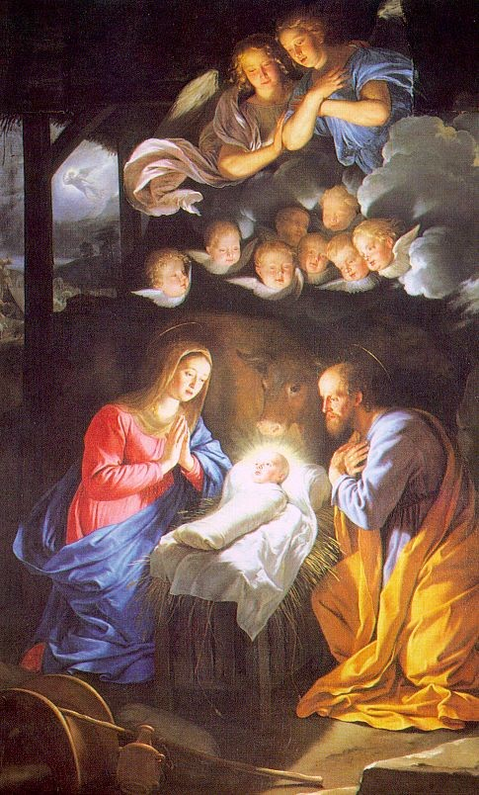

**This Bulletin is given to the Glory of God**

**and in Loving Memory of**

**our dear Parents, Rosa & Bob Chaytor**

**by their Children, Allison, Janice, Heather, Ruth, Sandy & Stephen**

**and their families**

www.stjohntheevangelistnl.com

Facebook: SJTE Topsail

Office email: sjtetopsail@nfld.net

Office phone number: 709 834-2336

Rector Email: jotienoel@gmail.com

Cell: 709 325-2366

***Our Parish Mission Statement***

***We believe in nurturing a community of faith dedicated to inclusion, support and sharing the story of God's love with all people regardless of the stage of their spiritual journey***

The Parish live-streams our regular Sunday Services and posts to Facebook

*And the Word became flesh and lived among us, and we have seen his glory, the glory as of a father’s only son, full of grace and truth. John 1: 14*

Who is God? God is answering that human question through God’s own enfleshment. Our gospel lesson for Christmas is the great, celebratory hymn to the Word. The challenge today is much the same as it has always been in our reception of God: to receive God as God comes to us. The jolt is not so much that God was in Christ, reconciling the world to himself—it’s that God was in Christ. “The Word (logos) became flesh,” is a stunning declaration of God’s availability.

A word becomes flesh and blood? The incomprehensible, wondrous logic of God has become a person? Yes, said Jesus’ first followers. The One who created the world—the One whom Israel was reluctant even to set eyes upon— has become a human being.

What matters most about God has become matter. Meaning has become material. As Luke might put it, the logic of the universe is embodied in a tiny baby. Or, as John says (literally, in the Greek, John 1:14), “the Word has tented among us.”

The world was created for this stunning moment so that God could tabernacle among us in Jesus Christ. The Christian faith is not common sense nor even a noble philosophy of life. It is in the reality of that person: fully God but embodied, up close and personal as a poor Jew from Nazareth.

Into the primal darkness, God says “light” and a benighted chaos comes alive (Gen 1). John’s gospel begins with that word “genesis”— “In the beginning….” Jesus is light like the first light of creation. Good news! The Word, the Eternal Word, the Word with God before time, has come to us, has moved in with us, and nothing will overcome this light!

“See, the home of God is among mortals, He will dwell with them as their God; they will be his people, and God himself will be with them;...” (Rev 20:3-4).

**Merry Christmas!** Canon Jotie, TSSF

*God of promise, from ancient times you have sustained your people.*

*With Mary and Joseph, teach us to treasure in our hearts the birth of Jesus,*

*and with shepherds and angels,*

*lead us to praise the holy Child of Bethlehem in whose name we pray. Amen. (ACC)*

**Parish Home Visits** – The dynamic of the times still provides many issues for clergy home visit ministry. As we continue to emerge out of the pandemic and still live with it, Canon Jotie is ready, willing, and able to visit you in your home. Under the circumstances, this offer comes with the understanding that he will respond to invitations. Please call him to invite him to visit your home if you wish for conversation, prayers, or Home Communion.

**The Laying on of Hands** – In preparation for the sacrament of Confirmation, in 2025, we plan to start Confirmation Classes in late January. Confirmation Candidates should currently be in Grade 6 or older. Please contact the Church Office to register or for more information (834-2336 or [sjtetopsail@nfld.net](mailto:sjtetopsail@nfld.net)).

We are ready, willing and able to prepare adults for Confirmation if you may be interested. Please contact Canon Jotie for details.

***Family Ukulele Group*** - The Family Ukulele Group is a music ministry of the parish and is open to ALL ages. No prior musically knowledge or experience is needed. Practice lessons are the first and third Sundays of each month immediately following the 10:30 service. We resume lessons in January 2025.  Ukuleles are available for purchase through the office for approximately $50. To register for the group call David at the office. Be sure to let him know if you will be needing a Ukulele. If you are unable to purchase one please contact Canon Jotie.

***Thanks from the Noel’s*** – To everyone who offered seasonal wishes, cards and gifts, we want to say a hearty thanks – Reverend Jotie & Pauline Noel.

**Sunday School** – We have used a variety of Programs for our Sunday School curriculum. Most recently, we have used Godly Play – a program widely recognized and encouraged in the Diocese. The commitment to offer this program is substantial. If you are interested in helping us reestablish a Sunday School program, we are open to other possibilities. We are able to use a number of options rather than Godly Play. We are familiar with:

* Sermons 4 Kids - Ready-made, little preparation required, includes a Lesson based on the one for each Sunday with a variety of activities for young people of various levels – colouring, puzzles, crafts, etc.
* Daily Bread for Kids – Ready-made, little preparation required, with a variety of resources available depending on the commitment and levels of our young people.

Please contact Canon Jotie (834-2336) if you are interested in helping to reestablish our Sunday School.

**We invite prayers for those who are sick**: Patricia B. Elaine M., Benjamin C., Doug T., Tammy H., Jeanette P., Wally H., Trudy T., Ruby H., Kelly R., Phyllis H., Eva B., Hayden P., Cynthia W., Scott S.

**Bible Study, New Year** – Our next Bible Study will be in January as we continue our study of Luke’s Gospel. We meet on Thursday morning in the Parish Hall at 10:30 a.m. for one hour. All are welcome.

***Bishop’s Christmas Letter 2024***

*“God with us”*

Dear Friends,

This Christmas marks my first holiday season without my beloved mother Elaine. She left us in February after a brave struggle with heart disease, and her absence is deeply felt. The air feels different this year; the festive lights seem dimmer, and the carols echo with a bittersweet tone. We all miss her radiant smile, the warmth of her hugs, and the simple joy of gathering around the table. The laughter and stories that once filled our home are overshadowed by our sense of loss. I know many of you carry a similar weight of loneliness during this time, and while the ache of missing Mom will linger, I find solace in the belief that she is now embraced by God's love.

As I reflect on my feelings of loneliness, I’m reminded that even in moments of deep sorrow, we are never truly alone. God’s comforting presence surrounds us, guiding us through times of darkness. The very name of Jesus encapsulates this promise. In the Gospel of Matthew, we find these powerful words: “Look, the virgin shall conceive and bear a son, and they shall name him Emmanuel,” which means “God with us.” (Matthew 1:23).

This promise of “God with us” is a powerful reminder that God’s unwavering love and presence surround us, no matter our circumstances. The Christmas story speaks to the depths of our hearts, reassuring us that hope prevails even amid our grief. The birth of Jesus, a precious gift to humanity, unveils the extraordinary depth of God’s love for each of us.

As we remember our loved ones this holiday season, I’m reminded of a beautiful story I heard from a friend. A few years ago, she experienced her first Christmas without her father, who had always been the heart of their family’s celebrations. His laughter and stories filled the room, and she feared the holiday would feel empty without him.

Determined to honour his memory, she decided to host the family gathering at her home despite her sadness. On Christmas Eve, as she prepared the house, she hung a large ornament on the tree - a cherished piece that her father had lovingly crafted many years before. As she placed it among the lights and decorations, she closed her eyes and recalled their time together, the laughter shared, and the lessons learned.

That evening, as family members began to arrive, she welcomed them with open arms, even as her heart felt heavy. Sensing her sadness, one of her younger cousins asked, “Why does the tree look so beautiful this year?” 2 Her answer broke the dam of her emotions. “It’s beautiful because it reminds me of him,” she replied, her voice trembling. “Each ornament tells a story of the love we shared.”

Inspired by her honesty, the family began to share their memories of her father, recounting funny and heartwarming stories. They laughed until tears streamed down their faces, and each shared memory ignited a flame of love that seemed to fill the room.

What unfolded was a night of connection, healing, and gratitude. They cooked together, reminisced, and comforted one another in their grief. She realized that by sharing her vulnerability, she had invited God's love into their midst. Their gathering was more than just a celebration of Christmas; it became a sacred space where love transcended loss.

As we gather this year, let us remember that the essence of Christmas is found in the relationships we foster and the kindness we show one another. In commemorating my mother this Christmas, I feel a strong urge to honour her legacy of love and compassion. I encourage you to reach out to someone who may be feeling lonely by offering a listening ear, sharing a warm meal, or simply spending time in their presence. Let us acknowledge the abundant blessings we have, even during challenging moments. By embodying the values our loved ones imparted - love, compassion, and faith - we can respect their memory.

As we gather with our families and friends this season, let us treasure these moments that weave the fabric of our lives. May we actively seek ways to extend warmth and kindness to those around us. Together, we can keep the light of hope and love glowing brightly in our hearts.

As we read in the Gospel of John about Jesus, *“In him was life, and that life was the light of all people. The light shines in the darkness, and the darkness did not overcome it.” (John 1:4-5)* May we illuminate these darker moments with the light of our togetherness, allowing God's love to shine through us and for us, reminding us all that we are never truly alone. I wish you all a Christmas filled with peace, the warmth of love, and the comforting presence of “God with us.”

In Christmas Light and Love,

The Right Rev. Samuel Rose, Bishop of Eastern Newfoundland and Labrador