|  |
| --- |
| **Worship Schedule**    **Sunday, November 3**, St. John the Evangelist ACW 75th Anniversary, **10:30 a.m.** (White) **Holy Eucharist** followed by a Cup O’ Tea In the Parish Hall (AG Team 1) (EA – Gail Trewhitt) (Proper for All Saints)  Isaiah 25: 6-9 Psalm 24 Revelation 21: 1-6a John 11: 32-44  **Remembrance Sunday, November 10**, Royal Canadian Legion joins us for The Blessing of the Colours, **10:30 a.m**. (White) **Morning Prayer**, Ukulele Ministry (AG Team 2) (Proper for All Souls)  Wisdom 3: 1-9 Psalm 116: 1-8 1 Peter 1: 3-9 John 6: 37-40  **Sunday, November 17, Pentecost 26, 10:30 a.m.** (Green) **Holy Eucharist** (BCP) (AG Team 3) (EA – Donald Sparkes)  1 Samuel 1: 4-20 Te Deum Hebrews 10: 11 – 14, 19 – 25 Mark 13: 1-8  **Sunday, November 24, The Reign of Christ** (White) **Holy Eucharist** (AG Team 1) (EA – Iain Hollett)  2 Samuel 23: 1 – 7 Psalm 132 Revelation 1: 4b – 8 John 18: 33 – 37 |

**A Note from the Treasurer:** Please ensure your **envelope number** is on all financial

correspondence so that we can credit your account for income tax purposes.

Regular Parish Office hours are Monday – Thursday, 9:00 a.m. – 1:00 p.m.

**Service Roster: Sides Persons Sound Room**

November 3rd Jo-Anne R. Jim S.

November 10th Rex H. Bob D.

November 17th Audrey M. Andrew B.

November 24th Betty P. Philip G.

|  |
| --- |
| Bishop: The Right Dr. Reverend Samuel Rose  Diocesan Administrator: The Venerable Charlene Taylor  Rector: The Reverend Canon Josiah “Jotie” Noel, T.S.S.F. (Third Order, Society of St. Francis)  Parish Deacon:  The Reverend Lisa Cox  Organists/Choir Director: Stephanie Gavell, Amanda Dawe-Ledwell  Parish Wardens: Rex Hillier & Donald Sparkes  Office Administrator: David Kelland |

**Welcome to the**

**Parish of St. John The Evangelist**

**Conception Bay South, Newfoundland**

**November 3, 2024**

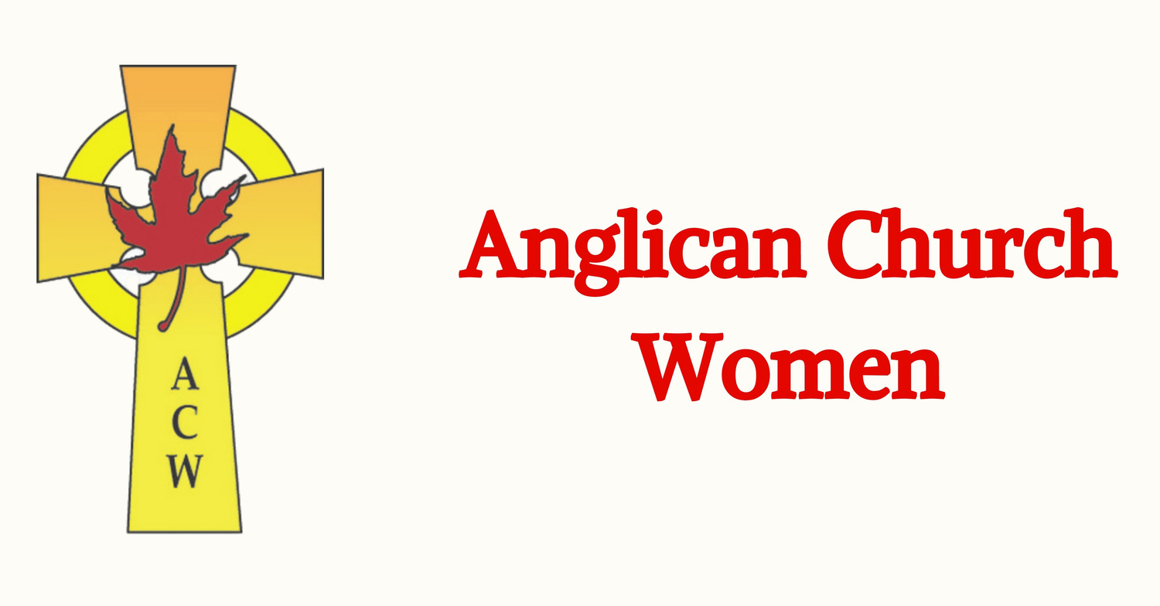

**ACW 75TH ANNIVERSARY**

www.stjohntheevangelistnl.com

Facebook: SJTE Topsail

Office email: sjtetopsail@nfld.net

Office phone number: 709 834-2336

Rector Email: jotienoel@gmail.com

Cell: 709 325-2366

***Our Parish Mission Statement***

*We believe in nurturing a community of faith dedicated to inclusion, support and sharing the story of God’s love with all people regardless of the stage of their spiritual journey*

The Parish live-streams our regular Sunday Services and posts to Facebook

**Blessing of the Saints** (From Abbey of the Arts)

May the communion of saints  
shower you with blessings,  
may you seek their guidance  
in moments of illness, confusion, gratitude.  
We remember their own struggles,  
living their humanity, enfleshed and tender.  
We ask those across the threshold to pray for us  
knowing what it is to be wounded.  
Call on the canonized saints,  
Benedict, Francis, Ignatius, Hildegard,  
Thea Bowman, Oscar Romero,  
and the saints of spirit,  
Howard Thurman, Dorothy Day,  
and thousands of others  
who witnessed to another way of being,  
who helped to build a community of love.  
Let them tether us to their earthiness,  
and remind us of the holiness  
of bone and blood, the grace of our bodies  
in bringing love to the world  
and the presence of heaven here and now.  
   
Feel them stretching themselves  
back across the veil toward us,  
in sacred friendship  
eyes shining, hearts radiant,  
wisdom pouring like rainfall,  
after months of drought,  
coming with a reminder  
that you are never alone,  
never forsaken  
and you dance in those life-giving  
showers, celebrate Love as a visible  
and invisible force, animating the world.

**On the occasion of it’s 75th Anniversary, the St. John the Evangelist ACW has given a donation to the to the Glory of God and in Loving Memory of all departed Sisters of the ACW.**

**We invite prayers for those who are sick**: Patricia B. Elaine M., Benjamin C., Doug T., Tammy H., Jeanette P., Wally H., Trudy T., Ruby H., Kelly R., Eva B., Hayden P., Cynthia W., Christine H., Danielle B., Denise P.

**Food Bank –** The food bank is currently in great need of cereal as well as canned milk – or take a decoration from our giving tree, purchase the item, and drop it off in our basket.

**Parish Home Visits** – Reverend Jotie is ready, willing, and able to visit you in your home. Under the circumstances of time and place, this offer comes with the understanding that he will respond to invitations. Please call him to invite him to visit your home if you wish.

**Bible Study, LUKE** – Our next Bible Study will be, Thursday, November 7th, at 10:30 a.m. Join us as we continue to study the Gospel of Luke references for Sunday worship. If you do not have a Bible, we can provide one for you, as well as a large print copy of the lesson for the study.

**Synod Prayer** - Heavenly Father, as the Diocese of Eastern Newfoundland and Labrador set sail into the waters of the upcoming Diocesan Synod, we pray for gentle winds of wisdom and unity to guide our path. May our hearts be open like sails to the breath of the Holy Spirit, leading us to new horizons of faith and cooperation. Let the waves of dialogue and understanding draw us closer to a shared mission, anchored in love and service. Bless this voyage with Your grace, granting safe passage and fruitful outcomes for all who walk this path together. Through Your Son, Jesus Christ, we pray. Amen.

**Sunday Bulletins** - If you’d like to give a weekly bulletin to commemorate the life of a loved one or in Thanksgiving for an event in your life, please contact David in the office for the dates available.

**Endowment Fund** – Our parish has established an Endowment Fund to enable you to offer a gift for the future life of our parish family. Pamphlets at the back of the Church describe options for your prayerful consideration.