|  |
| --- |
| ***Worship Calendar***  **Sunday, June 2nd, Pentecost 2**,  10:30 a.m. - (Green) Family Service  Followed by Cup O’ Tea in the Hall –  A good time to bring along your Recyclables & Donations to the Food Bank  S**unday, June 9th, Pentecost 3 – Jerusalem & Holy Land Sunday**  10:30 a.m. – (White) Holy Eucharist:  **Sunday, June 16th, Pentecost 4 National Indigenous Day of Prayer**  **(Father’s Day)**  10:30 a.m. – (Green) Holy Eucharist  **Sunday, June 23rd Pentecost 5**  10:30 a.m. – (White) Holy Eucharist: |

**A Note from the Treasurer:** Please ensure your **envelope number is on all financial correspondence** so that we can credit your account for income tax purposes.

**Parish Office hours are Monday – Thursday, 9:00 a.m. – 1:00 p.m.**

**Sunday Bulletins -** If you’d like to give a weekly bulletin to commemorate the life of a loved one or in Thanksgiving for an event in your life, please contact David in the office for the dates available.

***Service Roster:*** Sidespersons Sound Room

June 2nd John C. Andrew B.

June 9th Ken C. James S.

June 16th Dianne H. Philip G.

June 23rd. Leanne S. Robert D.

|  |
| --- |
| Bishop: The Right Reverend Samuel Rose  Diocesan Administrator: The Venerable Charlene Taylor  Rector: The Reverend Canon Josiah “Jotie” Noel, T.S.S.F. (Third Order, Society of St. Francis)  Parish Deacon:  The Reverend Lisa Cox  Organists/Choir Director: Stephanie Gavell, Amanda Dawe-Ledwell  Parish Wardens: Rex Hillier & Leanne Squire  Office Administrator: David Kelland |

**Welcome to the**

**Parish of St. John The Evangelist**

**Conception Bay South, Newfoundland**

**May 26, 2024**

Trinity Sunday

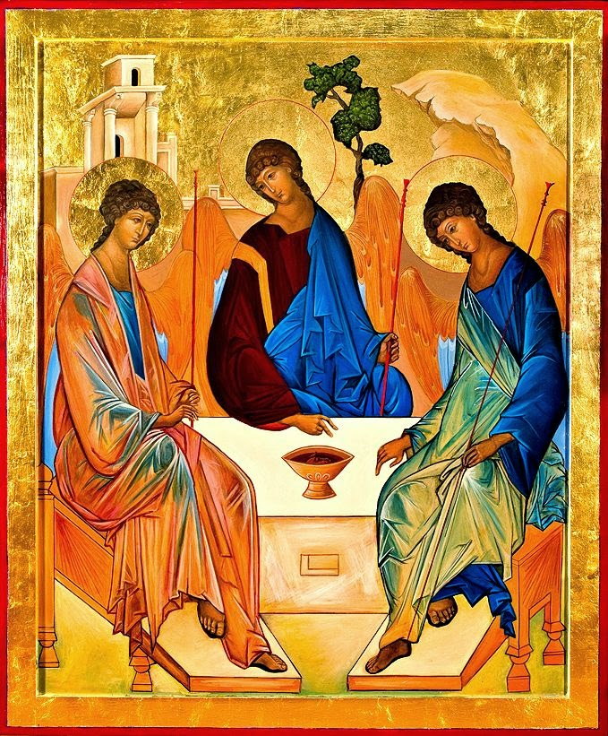

[www.stjohntheevangelistnl.com](http://www.stjohntheevangelistnl.com)

Facebook: SJTE Topsail

Office email: [sjtetopsail@nfld.net](mailto:sjtetopsail@nfld.net)

Office phone number: (709) 834-2336

Rector Email: [jotienoel@gmail.com](mailto:jotienoel@gmail.com)

Cell: (709) 325-2366

***Our Parish Mission Statement***

***We believe in nurturing a community of faith dedicated to inclusion, support and sharing the story of God's love with all people regardless of the stage of their spiritual journey***

The Parish live-streams our regular Sunday Services and posts to Facebook

*“I believe in God, the Father almighty, creator of heaven and earth.*

*I believe in Jesus Christ, his only Son, our Lord.*

*I believe in God the Holy Spirit.”*

The concept of Trinity is famously captured in art through an icon created in about 1410 by Andrey Rublev, regarded as one of the greatest medieval Russian painters of icons and frescoes. (A copy adorns the cover of our Bulletin)

This icon takes as its subject the mysterious story where Abraham receives three visitors as he camps by the oak of Mamre. He serves them a meal. As the conversation progresses, he seems to be talking straight to God, as if these 'angels' were in some way a metaphor for the three persons of the Trinity.

On one level this picture shows three angels seated under Abraham's tree, but on another it is a visual expression of what the Trinity means, what is the nature of God, and how we approach him. Reading the picture from left to right, we see the Father, the Son, and the Holy Spirit.

Contained in the center of the circle, a sign of death. The lamb, killed. The holy meal brought to the table. All points to this space, this mystery: within it, everything about God is summed up and expressed, his power, his glory, and above all his love.

This mystery is expressed in such a way that we can reach it. For the space at this table is on our side. We are invited to join the group at the table and receive the heart of their being for ourselves. We are invited to complete the circle, to join the dance, to complete the movements of God in the world by our own response.

*Holy One, whose fingers sculpted sun and moon;*

*Holy Spirit, who brooded over the waters of creation;*

*Holy Word, who lives in us;*

*may we share in your grace, love and communion,*

*so that we may live in your likeness;*

*for you live in unity and diversity, one God, now and for ever. Amen.(ACC)*

**Welcome –** This morning we have the pleasure towelcome our Bishop, Samuel Rose, our Presider and Chancel Chat guest. Please join us afterwards for a ‘cup o’ tea’ downstairs in the Parish Hall.

**Cemetery Clean Up -** Inviting volunteers to join us on Town Clean-Up Day, **June 8th, 9 a.m. – Noon** to collect garbage in our Cemetery. We will provide gloves, T-Shirts, and bags to any and all who may join us. We intend to maintain the standard of cleanliness we are accustomed to in our Cemetery. Contact Sharon Smith beforehand to ensure your gloves and T-Shirt are the correct size. Many hands make light work!

**Bible Study – LUKE** – **Wednesday, May 29th , 10:30 a.m.** Join us as we continue to study the Gospel of Luke references for Sunday worship. If you do not have a Bible, we can provide one for you, as well as a large print copy of the lesson for the study.

**Pilgrimage in the Park** – Chamberlain’s Park: **Monday, June 3rd, 10:30 a.m.**

Pilgrimage on any scale is an opportunity to awaken to the wonder and beauty of the world around us. In breaking from the daily routine, we are able to move out of our familiar ruts in order to re-examine our relationship with the MYSTERY OF LIFE. Our pilgrimages support opening and deepening awareness to the present moment, to our bodily senses, and to expanding conscious relationships with Creation as we seek and find in the Park. All are welcome.

**A Donation has been given to the Parish to the Glory of God and**

**In Loving Memory of Ralph & Betty Carter. Remembered by Wayde & Family**

**We invite prayers for those who are sick -** Patricia B., Elaine M., Benjamin C., Doug T., Tammy H., Jeanette P., Wally H., Trudy T., Ruby H., Kelly R., Phyllis H., Cynthia G., Eva B.

*Almighty and immortal God, the giver of life and health: We beseech thee to hear our prayers for thy servants for whom we implore thy mercy, that by thy blessing upon them and upon those who minister to them of thy healing gifts, they may be restored, according to thy gracious will, to health of body and mind, and give thanks to thee in thy holy Church; through Jesus Christ our Lord. Amen.*

***Parish Summer Job Opportunity***

Any **post secondary** Student that would be interested in working for the Parish in the Office and/or cemetery during July and August are asked to submit their resumes marked “Parish Summer Employment” to the Church Office. This position is for 8-week duration at 35 hours a week. Funding for this position has been approved by Employment and Social Development Canada - Canada Summer Jobs Program 2024. **Applications for the position** **must be submitted by June 10th**

***Cemetery Summer Employment -*** Any high school students (Grade X1 or X11) who may be interested in working at the Cemetery during July and August are asked to submit their resumes marked “Cemetery Summer Employment” to the Church Office. Any positions available are subject to the approval of application made by the parish to the Human Resources Student Programs 2024. **Applications for the positions** **must be submitted by June 10th.**

**Viability Forecast - Parish of St. John The Evangelist, Topsail**

To the keen eye our 2023 Annual Report revealed a truth that many might gloss over or choose to ignore. The Parish Budget for 2024 is actually a deficit budget! We acknowledge that our income for the Parish falls short of our expenses by $42,000.00. To balance the Budget the Vestry intends to withdraw $42,000.00 from the Land Sale Account (an investment the Parish has with Anglican Joint Investment).

If the Parish maintains its present income course over the next several years with no major financial gifts or major expenditure, our Treasurer, Ken Carter has informed the Vestry that we have six years before we will become a non-viable Parish. After that period, 2030, we will have to accommodate major changes in how we function (part-time clergy, reduced services, partner with another parish, etc.) like several neighbouring parishes in the Archdeaconry of the Avalon.

The Parish has several options:

* Bury our head in the sand and let time unfold, to be told in six years that the Parish has to face major Budget expenditure cuts consistent with our income.
* Take the lead in this forecast and prayerfully consider creative opportunities for action as we look to the future.

In consideration of the latter, the Vestry intends to prepare a Strategic Plan for the next 3, 5, and 7 years. While this may not stop the inevitable, it will call us to be fully informed and make intentional short/long term decisions for the health and well being of our Parish.

It is the best of times – it is an exciting time in the life of our faith community as we acknowledge the reality of the present to continue sailing forward despite the inclement weather forecast.

*Prevent us, O Lord, in all our doings with thy most gracious favour,*

*and further us with thy continual help.*

*That in all our works begun, continued, and ended in thee,*

*we may glorify thy holy name,*

*and finally by thy mercy obtain everlasting life;*

*through Jesus Christ our Lord. Amen. (BCP)*